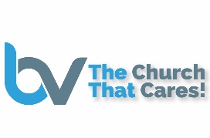

BVMBC 2023 Scholarship Application Checklist

______ Application form completed in its entirety*

______ 2 Letters of Recommendation (From Church Leaders)

______ Acceptance letter from a college or university

______ A graduation photograph.

______ A 350+ word Essay responding to the application question.
(use spell check, grammar check, and word count)

______ Submit as a complete package (All at one time)

______ Application must be received no later than Sunday, May 28th
(No Exceptions)

_______ Fee statement from college required before payment made.

